**Description of Datasets:**

1.Passwords.json:

* This dataset stores encrypted password information for various services.
* Format: JSON (JavaScript Object Notation)
* Encryption: Fernet symmetric encryption algorithm is used for securing the passwords within the dataset.

2.Key.key:

* This dataset contains the encryption key used to secure the `passwords.json` file.
* Format: Binary
* Generation: If not present, a new key is generated and stored.

**2. Modules:**

1.PasswordManager Class:

* Description: The core module encapsulating the password manager functionalities.
* Responsibilities:
* User authentication through hashed master passwords.
* Loading and managing the encryption key.
* Loading and decrypting the passwords.json file.
* Saving and encrypting password information.
* Adding, retrieving, listing services, and displaying passwords.

2.GUI (Tkinter):

* Description: Graphical User Interface module using the Tkinter library.
* Responsibilities:
* User interaction for setting the master password.
* Input fields for adding, retrieving, and managing passwords.
* Buttons for executing actions such as setting the master password, adding passwords, retrieving passwords, listing services, and exiting the application.

**3. Algorithms:**

1.User Authentication Algorithm:

* Description: Hashing user-entered master passwords for secure authentication.
* Algorithm: SHA-256 hashing algorithm is utilized for transforming the master password into a secure hash.
* Purpose: Verifying the authenticity of the entered master password.

2.Encryption Algorithm (Fernet):

* Description: Symmetric encryption algorithm for securing password data.
* Algorithm: Fernet encryption is employed to encrypt and decrypt the contents of the passwords.json file.
* Purpose: Ensuring the confidentiality of stored passwords.

3.Password Hashing Algorithm:

* Description: Hashing user-entered passwords before storing them in the dataset.
* Algorithm: SHA-256 hashing algorithm transforms passwords into secure hashes.
* Purpose: Adding an additional layer of security to stored passwords.

OUTPUT SCREENSHOTS:

**1.Entering master password**

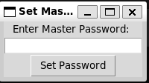

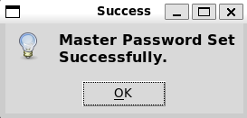

2.user interface for entering service, username & password

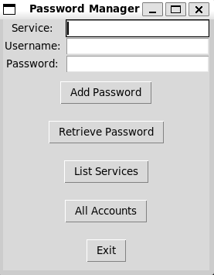 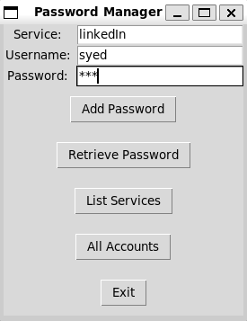

3.Setting password

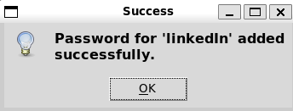

44.Listing of all services

